**Create Azure Web Jobs**

Many times we need to create web jobs to perform some task manually or scheduled which perform some task like getting data from Azure AD and creating CSV/JSON and upload to SP list. So we can create scheduled webjobs to run periodically and performs the task.

1. Navigate to <https://portal.azure.com/>
2. In the Search box type “App services” and select “App Services” from dropdown
3. Click Create >Select Subscription & resource Group> Provide name for web App
4. For Run time stack select .Net and add other details.

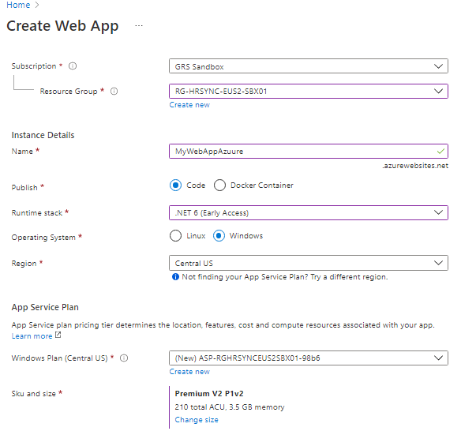

1. For Deployment Tab, we can keep continuous deployment as disabled

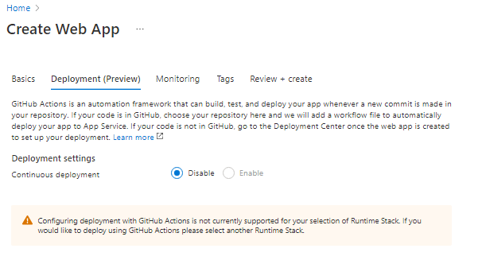

1. For Monitoring, we can enable if we want to use logging feature else we can select NO>Create
2. Once WebApp is created, click Go to resources > Select WebJobs from left panel under settings.
3. Click on Add from Web job page

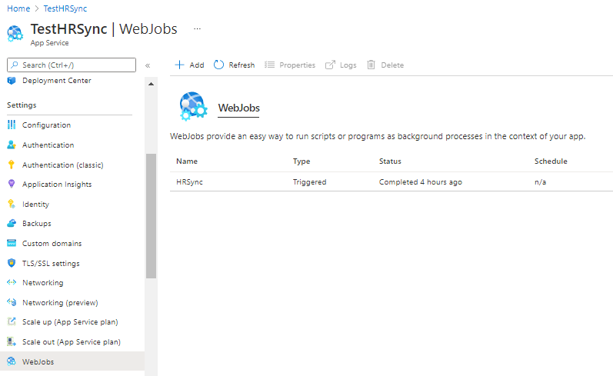

1. Create Package to upload for WebJob as
2. Create .ps1 file that connects the azure AD and perform task to create CSV/JSON file.
3. Create folder as Model and install both dependency of “PnP.PwerShell” and “Azure AD” inside Model folder.
4. Now Create a zip file of Model and .ps1 file and give some name. This file we will be using in next step. I have added one for reference.

**Note**: Write-Host is not supported in webjobs, so we need to write Write-output

1. Provide details of Add WebJobs

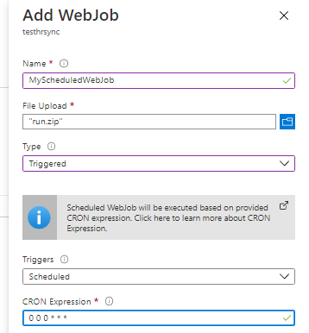

Note: I have created scheduled web job which will trigger everyday. You can check details on scheduling.

For Type it will be “Triggered” and Triggers it should be “Scheduled”. If we don’t want to create Scheduled Trigger, we can select Manual.

1. Select on the Log from top ribbon and can see all Logs and Error for any WebJobs. But If we want to register at central place for all logs and error we need to use “Application Insight”.

